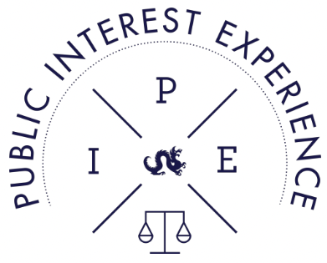
PIE PRIZE APPLICATION
February 20, 2026
Dear KSOL Classmates:

Thank you for your interest in our Public Interest Experience (PIE) Prize program. We’re excited to let you know that there will be funding available for 2026 summer employment. The amount of available funding depends largely on what we, the students, were able to do this year to raise funds. In this letter we’d like to tell you about the PIE Prize Board, the application process, and our current priorities.

THE PIE COMMITTEE
The PIE Committee is a group of students working primarily to raise funds for students’ Public Interest Experience summer prizes. It consists of individuals who were involved in the PIE Program and received prizes in previous years, as well as students who anticipate applying for future PIE Prizes.

THE PRIZE COMMITTEE & SELECTION PROCESS
The Prize Committee is a subset of the PIE Board which has drafted this application and will oversee the application process. The application process has been approved by the administration and is described for you on the following pages. Please note that all students seeking public interest employment are encouraged to apply, including those who received PIE prizes last year.

The application is due Monday, March 23, 2026 by 12:00pm. The Selection Committee will hold an interview with each applicant. After interviewing all applicants, the Selection Committee will determine the 2026 recipients. Prize Recipients will be announced by Monday, April 20, 2026. The Selection Committee is comprised of 3L students that are heavily involved in public interest projects and faculty/administration dedicated to the PIE mission.

PRIORITIES
The PIE Committee has identified two major priorities in selecting prize recipients. First is to further prepare students pursuing a career in public interest law to be experienced candidates for highly selective public interest jobs after graduation. Second is encouraging students’ enthusiastic involvement in the public interest sector, which can become a financial impossibility when public interest internships do not provide compensation. We value the full spectrum of public interest work, including direct client services and systemic advocacy.

To those students seeking funding for judicial internships: PIE Prizes will not be awarded to students seeking judicial internships. The PIE Committee has discussed this issue at length and has come to the conclusion that there may be instances when a student’s internship wholly aligns itself with the priorities described above. Currently, however, we recognize that most law school students throughout the country who work as judicial interns do so on a volunteer basis. Judicial internships mainly assist the efficiency of an individual judge, not the underrepresented parties who otherwise remain in need. In short, it is rare that a judicial internship will receive funding that is earmarked for PIE Prizes.

Our goal is to fund as many students as possible. Ideally, the PIE Committee would love to fund every student who applies. However, funding opportunities depend on - and are limited by - the amount of money we have raised. Additionally, we fully intend for students to maximize the use of Work-Study funds.

Lastly, we hope you’ll recognize that this effort has been manned by your fellow students. We are working very hard to ensure that money will be available to students this year so we all have the opportunity to access it. We’re happy to answer any questions you have after reading through the application packet. Email them to: PIEGrant@drexel.edu.

Thank you for taking the time to read through this letter. Good luck!
Yours,

PIE Auction Committee

THOMAS R. KLINE SCHOOL OF LAW
PUBLIC INTEREST EXPERIENCE PRIZES
2026 Application

WHAT ARE PUBLIC INTEREST PRIZES?

Public Interest Experience Prizes (PIE Prizes) provide stipends to Thomas R. Kline School of Law students who are taking unpaid, summer public interest positions. These students are committed to the public interest and intend to pursue a public interest career after law school. The purpose of the prize is to offset the costs of living for students who incur significant financial burden by taking an unpaid position for the summer. The Public Interest Experience Prize Board (PIE Prize Board) hopes students will gain invaluable experience, skills, contacts, and insight to further enable them to find employment after law school in the competitive practice of public interest law.

How do I qualify for a Prize?

In order to be eligible to receive a prize, students must volunteer to support the PIE Auction. Priority will be given to students who have shown exemplary involvement in the PIE Auction.

- 1L and 2L students currently enrolled at Thomas R. Kline School of Law are eligible to apply for a summer prize regardless of GPA; however, 2L students, students who have shown a commitment to public interest law, and students who submit outstanding applications may be viewed more favorably.
- The recipient must secure a position performing public interest legal work during the summer months of 2026. To qualify, the job placement must be both nonprofit and nonpartisan. Positions with the District Attorney or Public Defenders Association are also considered to be public interest. Students with unpaid judicial internships will not be considered for funding.

How much money can I expect to receive?

Funding will depend on the success of the PIE Auction and other student fundraising activities. Disbursements will be awarded considering, but not limited to, the following criteria:
- Commitment to and involvement in the PIE Auction and other fundraising events
- Full-time versus part-time work;
- Amount of financial assistance received through other sources, such as work-study (when available) or community grant;
- Specificity of the request; and
- The number of other students seeking prizes.
General Allocation Criteria:
- Allocation criteria will be considered on a case-by-case basis, with appropriate consideration given for full-time employment. If your project or placement does not fit the traditional criteria, describe your circumstances on a separate piece of paper.

Instructions:
- All applications must be submitted by Monday, March 23, 2026 no later than noon (12:00 pm)

- Provide your resume and certification page (included with packet).

- Applications MUST be submitted via email and should be submitted to PIEGrant@drexel.edu.

- Prize recipients will be announced by Monday, April 20, 2026.

What is required of a PIE Prize Recipient?

- Upon completion of their summer positions, PIE Recipients may be required to provide a short essay describing their summer experience working in the public interest sector. This essay may be printed in the Drexel Docket.
- PIE Prize Recipients are strongly encouraged to provide assistance with next year’s auction.
What is the selection process?
- The PIE Prize Board will assemble a Selection Committee of students, faculty, and members of the administration. This Selection Committee will select PIE Prize recipients and allocate funds. Only student members of the PIE Prize Board who are not applying for PIE Prizes themselves will be permitted on the Selection Committee.
- Each applicant will interview with a panel of students and faculty. The purpose of the interview is to get to know the applicant and clarify any questions which may arise from the application. All interviews are confidential and should last 15 - 20 minutes. Following the interview, the panel will discuss each application and make a recommendation to the larger Selection Committee.
The Selection Committee will then meet and make allocations of Prizes. Factors the Selection Committee will consider include:
- The certainty of the offer for a summer position;
- Whether the summer position fits the criteria for public interest as defined above;
- The applicant’s commitment to public interest work, as displayed by past work or desire expressed in the personal statement and interview;
- The applicant’s willingness to accept an unpaid position regardless of the guarantee of funding.
Questions?
Any questions can be directed to Rashida West at rtw27@drexel.edu.

CHECKLIST
- ________ Resume
- ________ Complete Application
- ________ Enclosed Statement of Interest
- ________ Certification Page
- ________ Submitted on Time

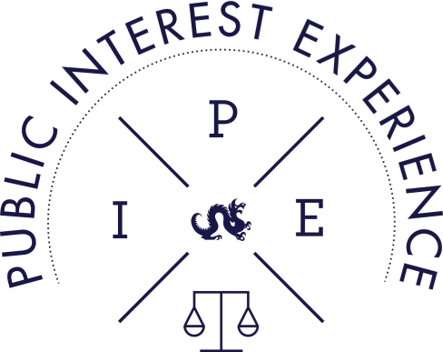
THOMAS R. KLINE SCHOOL OF LAW
PUBLIC INTEREST EXPERIENCE PRIZES
2026 Application
GENERAL APPLICATION INFORMATION
Name:
Address:
Telephone Number:
Email:
Expected Graduation Date:
Concentration:
Applying for: __ full time ____ part time ____ other (please describe on separate sheet)
Please describe any volunteer work done in the past 2 years (other than what is included in your resume):
Please describe any pro bono work done while in law school:
What other sources of funding are you planning on applying for? Besides the PIE Prize, what are your other forms of financial support?
Is there anything else that you would like to add about yourself?
Please describe your participation in the PIE Auction?
EMPLOYER INFORMATION
Name of Placement:
Projected Start and End Dates:
Name of Supervisor:
Phone of Supervisor:
Email of Supervisor:
General Overview of Placement:

How many hours a week do you expect to work?:

STATEMENT OF INTEREST
Please submit a short statement of interest (a couple of sentences to a paragraph), briefly describing the nature of any previous public interest experiences, your future plans, if any, for public interest work, and how your proposed internship relates to your goals.

THOMAS R. KLINE SCHOOL OF LAW
PUBLIC INTEREST EXPERIENCE PRIZES
2026 Application Statement of Intent
I am applying for a Thomas R. Kline School of Law Public Interest Experience Prize for the summer of 2026. In submitting this application, I certify that all of the following statements are true:
____ I have read the entire 2026 PIE Prize application. I understand its contents and agree to abide by the rules and regulations outlined therein. Furthermore, I have complied with all the application guidelines.
____To the best of my knowledge, all the information submitted in support of my PIE Prize application is complete and accurate.
____I understand that I may earn money from additional sources and I agree to truthfully disclose such information so that the PIE Prize Board can accurately assess my financial status in order to fairly award prizes to applicants.
____If awarded a PIE Prize, I will work in the position listed in my application (or listed in an approved amendment to my application) for the time period approved by the PIE Prize Board.
____I understand that my award is contingent upon my continued enrollment at the Thomas R. Kline School of Law.
____I understand that if I am terminated from or discontinue my public interest employment before its expected completion, I must return the amount of received prize money that is proportionate with the amount of work not completed.
___I understand that failure to comply with any of the above conditions may be grounds for the Thomas R. Kline School of Law to remove my application from consideration, or undertake other disciplinary action, as it deems appropriate.

